INSTRUCTIONS FOR FULL-LENGTH MANUSCRIPT PREPARATION (BOLD CAPITAL, Times New Roman, 14pt)

Name SURNAME¹ and Name SURNAME² (Times New Roman, 12pt)

¹First author’s affiliation, City, Country (Times New Roman, 11pt, italic)
²EDF R&D, Chatou, France

Keywords: a list of keywords fitted in one line (Times New Roman, 12pt).

ABSTRACT: The full paper will be published for electronic copy as the conference proceeding and should be within a limit of 10 pages. Please follow the format and the style described in this template. You can use this template for preparing your full paper. The paper should be submitted in an electronic form (MS Word and pdf file) via email to iahr.ictc2017@gmail.com (copy franck.david@edf.fr and benoit.makke@edf.fr) by 15 July 2017.

1 STANDARD SETTINGS

1.1 Typing

Fonts, sizes and spacing should be used as shown in this template. Page size is A4 (210 mm x 297 mm), the margin settings are: top: 2.0 cm; bottom, left and right: 2.55 cm. Type font of text is Times New Roman, 12pt, single spacing, justified. For tables, figures, references and authors affiliation use type size 11pt, for the title 14pt bold capital. Each paragraph is separated by a blank line. No indentations should be used. There should be no blank line in the first line of a page.

1.2 First Page

In the first line the name of the conference (18th IAHR International Conference on Cooling Tower and Heat Exchanger, 16-20 October 2016, Lyon, France) is placed right-aligned (type size 12pt) followed by a horizontal line. After this line there are 5 blank lines. The title is written centered in Times New Roman, 14pt bold capital, single spacing and should have a maximum of 2 lines. Then again 2 blank lines. The authors are written centered in Times New Roman, 12pt, in the form Name SURNAME without using an academic title. The surname is written in small capitals. After one blank line type the affiliation of the author(s). If there are different affiliations for the authors use one line for each and assign them to the surnames by indices. 5 blank lines are following.

After “Keywords:” fill in a list of not more than one line including the word keywords. 1 blank line follows. In chapter “ABSTRACT:” (without a chapter number) a short summary should be provided describing the principal subject and purpose of the paper. It should not exceed 10 lines.

1.3 Headings

Main Headings should be written in capital letters, Times New Roman, 12pt, single spacing. Subheadings should be written in Times New Roman, 12pt, italic, single line spacing. Sub-subheadings are Times New Roman, 12pt, single line spacing. Headings should be left-aligned with the title beginning 1 cm from the left edge and be limited to three levels and numbered appropriately using the decimal system.
Provide 1 blank line between all sections and 2 blank lines before a new main heading (which includes “Acknowledgement” and “References”).

1.4 Page Numbering

Do not use page numbering in your paper.

2 FIGURES AND TABLES

Figures and tables and there captions should be centered. Use Times New Roman, 11pt, single spacing for captions and also for lettering in figures and tables. Captions of figures and tables have to be numbered separately like “Figure 1: …” and “Table 1: …” and written below the respective figure or table. References should be abbreviated as follows: “Fig. 1” and “Tab. 1”. Figures and tables not cited in the text should not be presented.

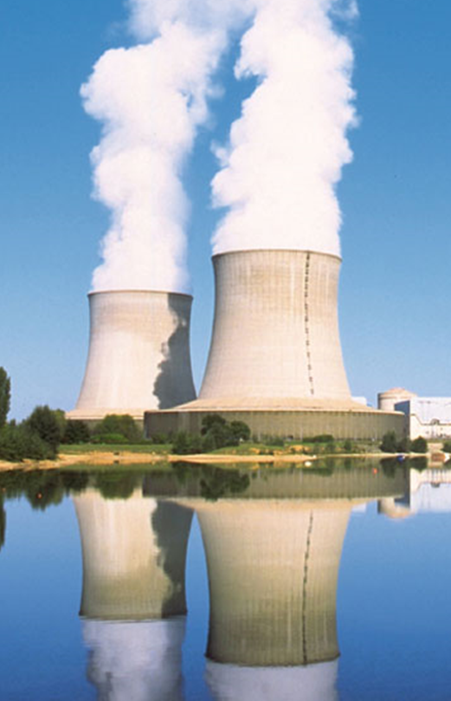

Figure 1: Title of example figure

3 EQUATIONS

Insert all equations using the equation editor of MS-Word with type font Cambria Math and type size 11. The equations should be centered and numbered consecutively with the number shown in parentheses (1) right-aligned. Above and below the equation there is 1 blank line.

(𝑧)=𝑟0+𝑎𝑏√𝑏2+(𝐻𝑇−𝑧)² (1)

References should be abbreviated with “Eq. (1)”.

4 SUBMISSION

The paper should be submitted in an electronic form (MS Word and pdf file) via email to franck.david@edf.fr or iahr18@tobeprecised by 15 July 2017.

ACKNOWLEDGEMENTS (without chapter number)

This template is similar to the IAHR 2015 conference in Brisbane. The organizing committee of this conference thanks Dr Guan and Prof. Harte for their contribution.

Acknowledgements may be addressed at the last paragraph of the text.

REFERENCES (without chapter number)

References should be listed in alphabetical order, in Times New Roman, 11pt. In the text the citation should be made by placing the authors’ last names and the year of publication in parentheses – e.g. (Harte & Wittek 2009) or (Kröger 2004).

Harte R, Wittek U 2009. Recent developments of cooling tower design, Proc. of IASS Symposium 2009, Valencia, Spain, Sept.-Oct. 2009, 198 – 210.

Kröger DG 2004. Air-cooled heat exchangers and cooling towers, Volume I. Tulsa, Okla.: PennWell.

Surname name initials year. Title of article. Title of Journal volume number (issue number): page numbers xx – xx.

Surname name initials year. Book title. City: Publisher

